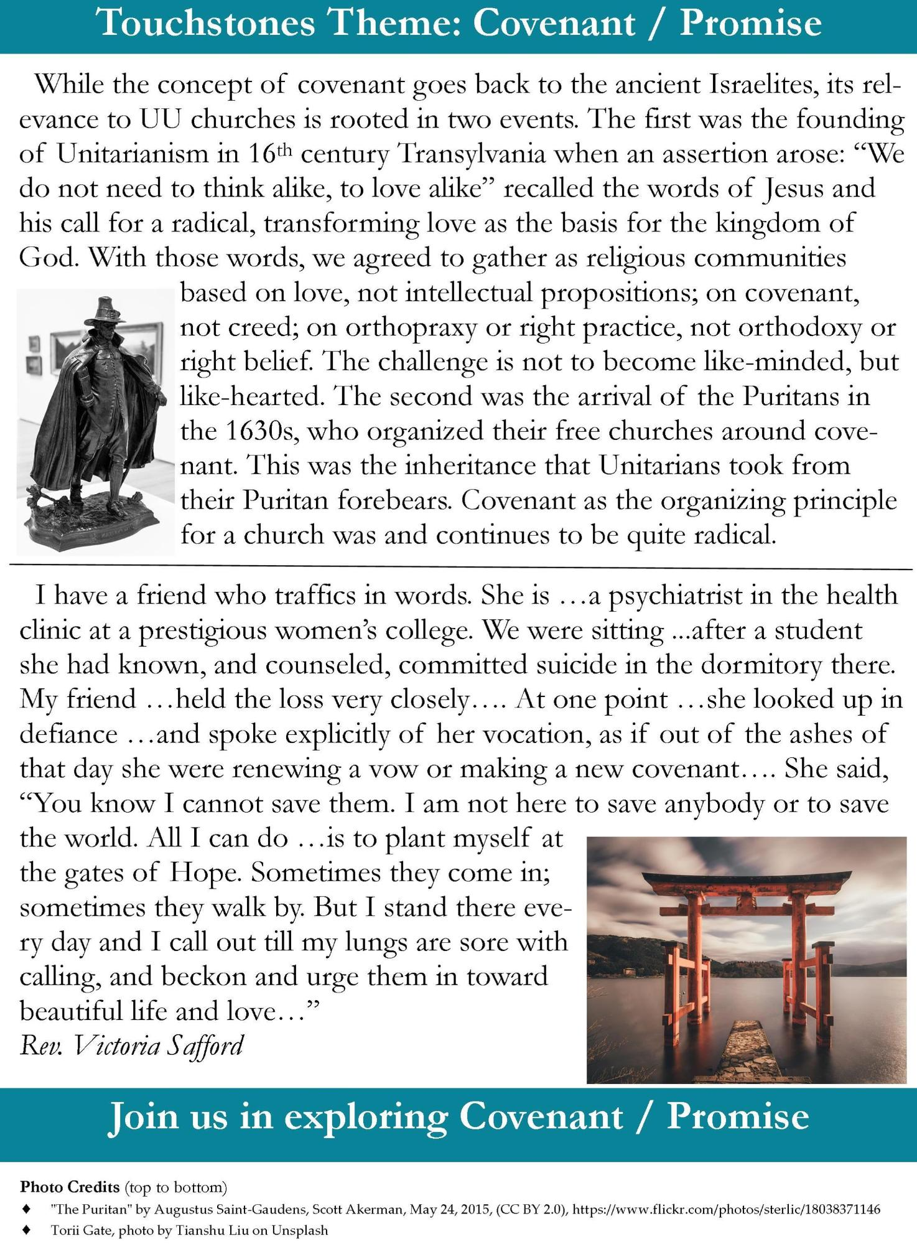
Touchstones Theme: Covenant / Promise
While the concept of covenant goes back to the ancient Israelites, its relevance to UU churches is rooted in two events. The first was the founding of Unitarianism in 16th century Transylvania when an assertion arose: “We do not need to think alike, to love alike” recalled the words of Jesus and his call for a radical, transforming love as the basis for the kingdom of God. With those words, we agreed to gather as religious communities
based on love, not intellectual propositions; on covenant, not creed; on orthopraxy or right practice, not orthodoxy or right belief. The challenge is not to become like-minded, but like-hearted. The second was the arrival of the Puritans in the 1630s, who organized their free churches around covenant. This was the inheritance that Unitarians took from their Puritan forebears. Covenant as the organizing principle for a church was and continues to be quite radical.
I have a friend who traffics in words. She is ... a psychiatrist in the health clinic at a prestigious women's college. We were sitting ...after a student she had known, and counseled, committed suicide in the dormitory there. My friend ...held the loss very closely.... At one point ...she looked up in defiance ...and spoke explicitly of her vocation, as if out of the ashes of that day she were renewing a vow or making a new covenant.... She said, “You know I cannot save them. I am not here to save anybody or to save the world. All I can do ...is to plant myself at the gates of Hope. Sometimes they come in; sometimes they walk by. But I stand there every day and I call out till my lungs are sore with calling, and beckon and urge them in toward beautiful life and love...” Rev. Victoria Safford
Join us in exploring Covenant / Promise
Photo Credits (top to bottom)
"The Puritan" by Augustus Saint-Gaudens, Scott Akerman, May 24, 2015, (CC BY 2.0), https://www.flickr.com/photos/sterlic/18038371146 Torii Gate, photo by Tianshu Liu on Unsplash

